Mhammed Alhayek

RUID: 156-00-6919

Programming Methodology Homework 6

Question 1:

1. Page 632 Exercise 1:
2. Adjacency Matrix for Figure 20-33:

|  |  |  |  |  |  |  |
| --- | --- | --- | --- | --- | --- | --- |
|  | 0 | 1 | 2 | 3 | 4 | 5 |
| 0 | ∞ | 9 | ∞ | ∞ | 1 | ∞ |
| 1 | 9 | ∞ | 8 | ∞ | 6 | ∞ |
| 2 | ∞ | 8 | ∞ | 5 | ∞ | 2 |
| 3 | ∞ | ∞ | 5 | ∞ | ∞ | ∞ |
| 4 | 1 | 6 | ∞ | ∞ | ∞ | 7 |
| 5 | ∞ | ∞ | 2 | ∞ | 7 | ∞ |

Adjacency List for Figure 20-33:

I

4

1

1

9

0

\

4

6

2

8

0

9

1

5

2

3

5

1

8

2

2

5

3

5

7

1

6

0

1

4

4

7

2

2

5

1. Adjacency Matrix for Figure 20-34:

|  |  |  |  |  |  |  |  |  |  |
| --- | --- | --- | --- | --- | --- | --- | --- | --- | --- |
|  | a | b | c | d | e | f | g | h | i |
| a | 0 | 1 | 1 | 0 | 0 | 0 | 0 | 0 | 0 |
| b | 0 | 0 | 0 | 1 | 0 | 0 | 0 | 1 | 0 |
| c | 0 | 0 | 0 | 1 | 1 | 0 | 0 | 0 | 0 |
| d | 0 | 0 | 0 | 0 | 0 | 0 | 0 | 1 | 0 |
| e | 0 | 0 | 0 | 0 | 0 | 0 | 1 | 0 | 0 |
| f | 0 | 0 | 0 | 0 | 0 | 0 | 1 | 0 | 1 |
| g | 0 | 0 | 1 | 0 | 0 | 0 | 0 | 0 | 0 |
| h | 0 | 0 | 0 | 0 | 0 | 0 | 1 | 0 | 0 |
| i | 0 | 0 | 1 | 0 | 0 | 0 | 0 | 0 | 0 |

a

b

c

d

e

f

g

h

i

b

c

d

h

d

e

h

g

c

g

c

g

i

Adjacency List for Figure 20-34:

1. Page 633, Exercise 11
   1. 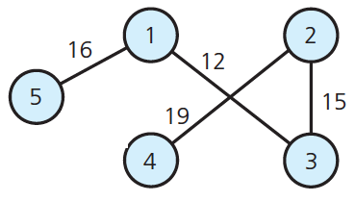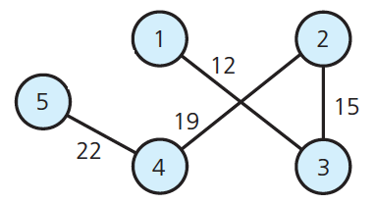All possible spanning trees:

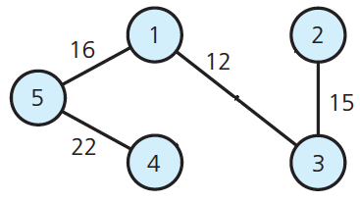

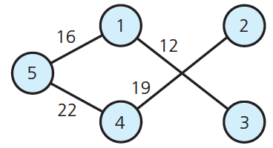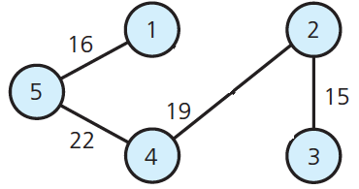

* 1. The Minimum Spanning Tree:



Question 2: Using the topological sorting algorithm topSort1, as given in this chapter, write the topological order of the vertices for each graph in Figure 20-37.

1. Topological Order: adebc
2. Topological Order: adbc
3. Topological Order: aedbc

* Note: when given choice of vertices to remove, I removed vertices in alphabetical order.
* See attached sheet for trace.

Question 3: Code submitted on sakai. Implementation submitted shows two methods, one that uses 0 as the origin, and one allows for an input to choose any origin. Modifying the algorithm consisted of simply changing 2 lines of code, which can be observed in the cpp file. Instead of initializing weight[v] to graph[0][v], it was initialized to graph[source][v]. The other modification was initializing weight[source] to 0.